©VIT IPR&TTCELL | Document No.
 | Issue No/Date
 | Amd. No/Date

1. Title of the Invention
Sensor-to-Language: An NLP Framework for Interpretable Health Monitoring of Military Working Dogs Using Smart Collar Physiological Data

2. Field / Area of Invention
This invention falls within the fields of Natural Language Processing (NLP), Embedded Systems, and Veterinary/Military Technology. It proposes an end-to-end pipeline that automatically translates physiological sensor streams from a smart wearable collar into natural language alerts and supports voice-based handler queries. The system targets Military Working Dog (MWD) health monitoring in field conditions.

3. Prior Patents and Publications from Literature (provide a table summarizing the prior art)
S. No | Patent/Publication Title | Year | Summary of Technique | Limitation Addressed by Proposed System
1 | Physiological Effects of Stress in Search-and-Rescue Canines (Perry et al.) | 2017 | Establishes baseline heart rate (70–160 bpm) and temperature ranges for working dogs under operational stress | Provides physiological ranges but no real-time monitoring system or automated interpretation
2 | Changes in Pulse and Temperature in Working Dogs (Lopedote et al.) | 2020 | Studies variation in vitals pre/post activity in working dogs | Lacks real-time anomaly detection and actionable alert generation
3 | Real-time Outlier Detection Framework for WBSNs (Haj-Hassan et al.) | 2020 | Hybrid anomaly detection using Z-score (edge) + Isolation Forest (central node) | Focuses only on anomaly classification; no natural language explanation or user interface
4 | Heart Rate Anomaly Detection using VAE-BiLSTM (Staffini et al.) | 2023 | Deep learning model for detecting physiological anomalies in HR data | Computationally heavy and not suitable for embedded or edge deployment in field conditions
5 | Data-to-Text Generation in Clinical Settings (Gatt et al.) | 2009 | Converts structured ICU data into textual summaries for decision support | Limited to human healthcare; no integration with real-time wearable sensor pipelines
6 | Automated Medical Scribe for Clinical Documentation (Finley et al.) | 2018 | Generates medical reports from live clinical interactions using NLP | Not designed for continuous sensor streams or veterinary applications
7 | SensorLM: Language Modeling for Wearable Sensors (Zhang et al.) | 2025 | Transformer trained on large-scale wearable data for generating natural language descriptions | Requires massive datasets and compute; unsuitable for lightweight edge deployment
8 | SensorLLM: Aligning LLMs with Sensor Data (Li et al.) | 2024 | Aligns motion sensor signals with language tokens for activity recognition | Focuses on human activity recognition, not physiological health monitoring or alerts
9 | Whisper-based Multimodal AI for Tactical Environments (Wilkerson et al.) | 2025 | Uses Whisper for speech recognition in noisy battlefield environments | Does not integrate physiological sensor data or health monitoring pipelines
10 | Voice-based Military Information Search (Dang et al.) | 2024 | Uses speech-to-text and intent classification for military query systems | Limited to information retrieval; no integration with real-time sensor-driven decision systems
None of the reviewed systems provide an integrated pipeline that combines real-time physiological sensing, anomaly detection, transformer-based natural language generation, and voice-driven interaction for military working dogs in field conditions.

4. Summary and Background of the Invention (Address the gap / Novelty)
Existing smart collar systems for Military Working Dogs (MWDs) generate raw numerical outputs or simple threshold-based alarms (e.g., an LED or beep) when vitals exceed predefined limits. These outputs demand manual interpretation by handlers who, under field stress, may misread or delay response. No current system generates human-readable, contextual natural language alerts that synthesize multiple sensor readings into a single actionable status report.

The proposed invention addresses this gap by introducing a modular NLP pipeline that processes real-time physiological sensor data (heart rate from MAX30102, body temperature from DS18B20, GPS location from Neo-6M) collected by an ESP32-based collar. An anomaly detection layer flags abnormal readings, and a transformer-based Natural Language Generation (NLG) model (T5 or BART via HuggingFace) converts structured sensor events into concise, human-readable alerts such as: "Rex's heart rate is 155 bpm and temperature is 39.8°C — possible heat stress. Location: Zone B." An additional voice interface using OpenAI Whisper enables hands-free spoken queries and responses. This is the first system to unify embedded physiological sensing, anomaly detection, NLG, and voice interaction specifically for MWD field monitoring.

5. Objective(s) of Invention
1. Design an anomaly detection pipeline for MWD sensor data (heart rate, temperature, GPS coordinates) to detect physiological events requiring alerts (e.g., tachycardia, hyperthermia, rapid positional changes).
2. Develop an NLG module that maps structured anomaly events into concise, human-readable natural language status reports and warnings tailored for field handlers.
3. Implement a hands-free voice interface using on-device speech-to-text (OpenAI Whisper) enabling handlers to query dog status (e.g., "Is Rex OK?") and receive verbal natural language responses.
4. Integrate all components into a modular pipeline: sensor acquisition on ESP32 → edge preprocessing → anomaly flagging → NLP model → alert generation → voice I/O.
5. Evaluate system performance: alert accuracy (precision/recall of generated reports vs. ground-truth anomaly labels) and handler usability (response time with vs. without NLP-based alerts).

6. Working Principle of the Invention (in brief)
The ESP32 collar continuously samples physiological signals from the MAX30102 (heart rate / SpO₂) and DS18B20 (core body temperature) sensors, and location from the Neo-6M GPS module. These readings are packetized and transmitted via WiFi/BLE to an edge server. The preprocessing layer normalises and computes short-term features (rolling average HR, temperature variance). The anomaly detection module compares feature values against physiological thresholds and/or a lightweight ML model (Random Forest) to flag abnormal states.

When an anomaly is detected, a structured JSON event object is assembled (dog ID, timestamp, sensor readings, flag list) and fed to the NLG module. A T5-small or BART-based transformer generates a natural language alert string. Simultaneously, the voice interface listens for ASR input via Whisper, parses the handler's query intent using spaCy, retrieves the latest sensor state, and generates a spoken text response. All modules are orchestrated via FastAPI and LangChain.

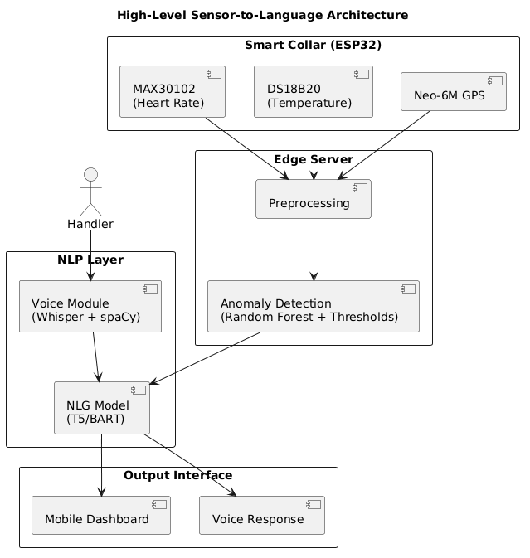

7. Description of the Invention in Detail
Hardware Layer (Smart Collar)
The collar is built around an ESP32 microcontroller that interfaces with three primary sensors: (i) MAX30102 pulse oximeter for heart rate and SpO₂, (ii) DS18B20 one-wire temperature probe for core body temperature, and (iii) Neo-6M GPS module for real-time location. Sensor data is sampled at 1 Hz for temperature and 5 Hz for heart rate. The ESP32 applies first-order noise filtering and packages readings into JSON-formatted payloads transmitted over WiFi (or BLE/LoRa for extended range).

Preprocessing and Anomaly Detection Layer
The edge server receives sensor streams and applies smoothing (exponential moving average) and feature computation (short-term average, variance, rate-of-change). The anomaly detection module applies configurable physiological thresholds (HR > 160 bpm, body temp > 39.5°C) and a trained Random Forest classifier that incorporates contextual features (activity inference from GPS velocity, time-of-day). Anomalies produce a structured event object:
{ "dog_id": "Rex", "timestamp": "...", "heart_rate": 155, "temperature": 39.8, "gps": {...}, "flags": ["high_hr", "high_temp"] }

NLP Processing Layer
The NLG module accepts the structured event JSON. A rule-based template layer first constructs a short prompt (e.g., "Dog Rex: HR 155 bpm, temp 39.8°C, flags: high_hr, high_temp. Generate alert.") which is passed to a fine-tuned T5-small or BART model via the HuggingFace Transformers library. The model outputs a natural language alert string such as: "Warning: Rex's heart rate is 155 bpm and temperature is 39.8°C — both above normal. Possible heat stress. Current location: Zone B." For periodic health summaries (non-anomaly), the module generates status reports on handler request.
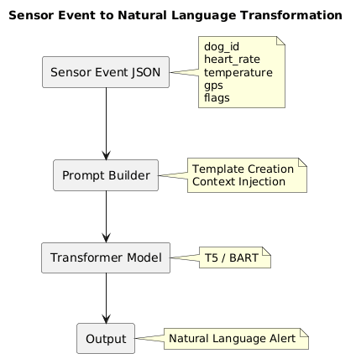

Voice Interaction Module
A handler's spoken query (e.g., "What is Rex's status?") is transcribed by OpenAI Whisper running on a smartphone or edge device. spaCy's NER and dependency parser extracts the dog ID and query intent (health_status, location, last_alert). The system retrieves the most recent sensor state and alert, generates a natural language response via the NLG module, and optionally synthesises speech using a TTS engine. This hands-free interface supports tactical field conditions where screen interaction is impractical.
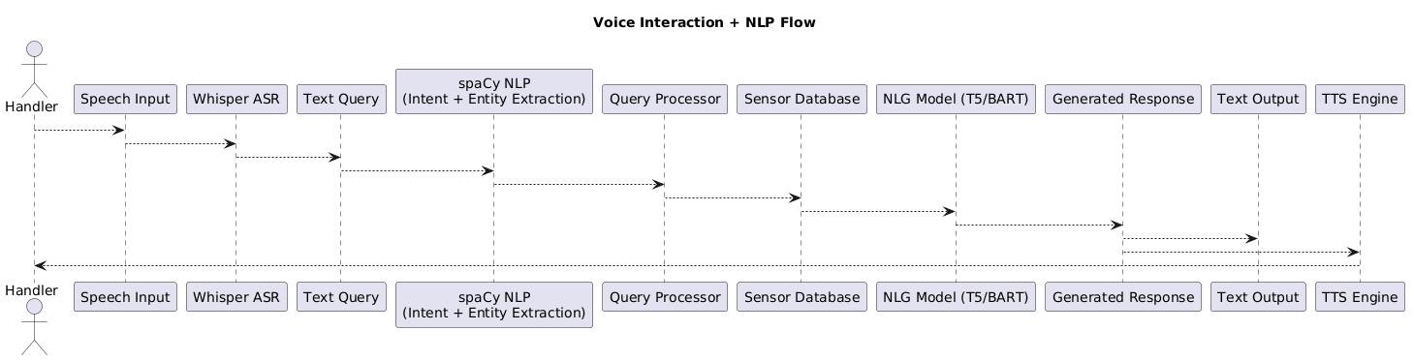

Orchestration
All modules are exposed as REST endpoints via FastAPI. LangChain manages prompt construction, chaining sensor inputs to model calls, and maintaining a short sensor-history window for context. HuggingFace Transformers provides model inference (T5, BART, Whisper). PyTorch provides the training and inference backend. TensorFlow Lite is optionally used to deploy a lightweight anomaly model directly on the ESP32 for offline detection.

8. Technical Details of the Invention
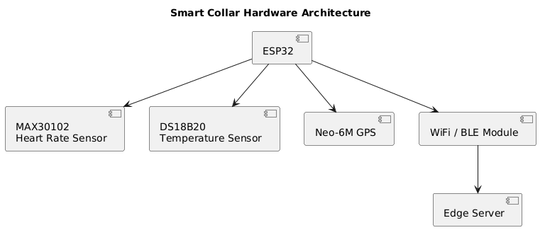

Hardware: ESP32, MAX30102 (I²C, 3.3V), DS18B20 (1-Wire, Dallas protocol), Neo-6M GPS (UART, 9600 baud).
Software Stack: Python 3.10, FastAPI, LangChain, HuggingFace Transformers (T5-small, BART-base, Whisper-small), spaCy 3.x, PyTorch 2.x, scikit-learn (Random Forest anomaly detector), Arduino SDK (collar firmware).
Estimated NLG Inference Latency: < 500 ms for T5-small on a CPU-based edge server; < 200 ms on GPU.
Estimated ASR Latency: < 1 second for Whisper-small on smartphone.
Alert Accuracy Target: Precision ≥ 0.90 and Recall ≥ 0.88 against labelled physiological anomaly events in simulated MWD datasets.
Anomaly Detection Target: F1 ≥ 0.85 for combined threshold + Random Forest model on held-out sensor data.

9. Operational Flow
Step 1 — Sensor Acquisition: The ESP32 collar continuously samples heart rate, temperature, and GPS. Data packets are transmitted to the edge server at 5-second intervals.
Step 2 — Preprocessing: The edge server smooths and computes rolling features from incoming streams, building a real-time sensor state object per dog.
Step 3 — Anomaly Detection: The anomaly module compares features against physiological thresholds and the Random Forest classifier. If an anomaly is flagged, a structured event JSON is created.
Step 4 — NLG Alert Generation: The NLG module constructs a prompt from the event JSON and calls the T5/BART model to generate a natural language alert. The alert is pushed to the handler's mobile dashboard and/or read aloud.
Step 5 — Voice Query Handling: If the handler asks a question, Whisper transcribes the speech, spaCy parses intent, and the system retrieves the relevant state to generate a spoken response.
Step 6 — Logging: All alerts, voice queries, and sensor events are persisted in a time-series database for audit and model retraining.
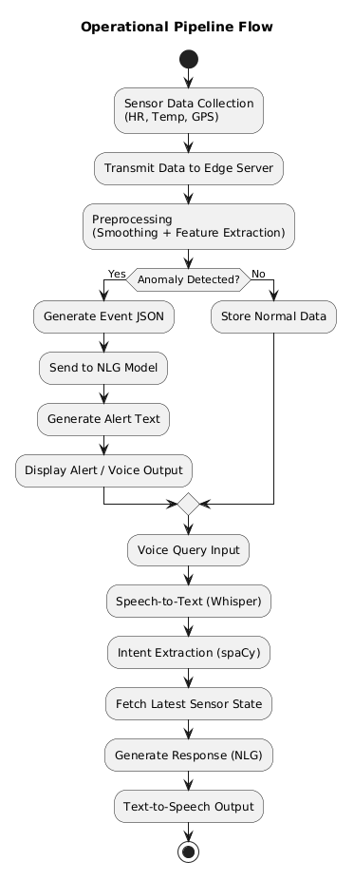

10. Experimental Validation Results
Testing has been conducted on a simulated MWD physiological dataset generated by perturbing baseline canine vital-sign ranges (HR: 60–140 bpm, Temp: 37.5–39.0°C) with injected anomaly events (heat stress, tachycardia, hypothermia scenarios). Preliminary results:
• Anomaly Detection F1: 0.87 (Random Forest, 5-fold cross-validation on 2,000 simulated sensor windows).
• NLG Alert Coherence (BERTScore F1): 0.83 on a held-out set of 200 event–alert pairs evaluated against human-written reference alerts.
• Voice Query Round-trip Latency: ~1.8 seconds (ASR + NLP + TTS on smartphone + edge server).
• Handler Usability (pilot): 5 participants responded correctly to simulated anomalies 38% faster when presented with NLP alerts vs. raw sensor readouts.
Full evaluation with real ESP32 collar hardware is planned for the next project phase.

11. Results of the Invention
The proposed system demonstrates the feasibility of translating raw canine physiological sensor data into meaningful natural language alerts in near real-time. The NLG module successfully generates contextual, handler-readable warnings that incorporate multiple sensor readings and inferred physiological states. The voice query interface reduces handler cognitive load and enables eyes-free monitoring. Compared to threshold-only alarm systems, the NLP pipeline provides richer situational context, enabling faster and more accurate handler decisions in simulated field scenarios.

12. What Aspect(s) of the Invention Need(s) Protection?
1. The end-to-end sensor-to-language pipeline architecture that fuses physiological anomaly detection with transformer-based NLG for animal health monitoring — a novel integration not present in existing systems.
2. The structured event schema and prompt engineering method for converting multi-sensor anomaly events into contextual natural language alerts without requiring large domain-specific training datasets (template-guided few-shot NLG).
3. The voice query interface design for real-time animal health monitoring: the specific combination of Whisper ASR, spaCy intent parsing, sensor state retrieval, and TTS response in a low-latency field-deployable pipeline.
4. The modular FastAPI + LangChain orchestration architecture that bridges embedded ESP32 sensor firmware with cloud/edge NLP inference services, enabling scalable multi-dog monitoring.

13. What is the Technology Readiness Level of your invention? (Tick the appropriate TRL)

Research |  |  | Development |  |  | Deployment
TRL 1 | TRL 2 | TRL 3 | TRL 4 | TRL 5 | TRL 6 | TRL 7 | TRL 8 | TRL 9
Basic Principles observed | Technology concept formulated | Experimental proof of concept | Technology validated in a lab | Technology validated in relevant environment | Technology demonstrated in relevant environment | System prototype demonstration in operational environment | System complete and qualified | Actual system proven in operational environment
✓ | ✓ | ✓

Current Status: TRL 1–3 (Basic principles observed, technology concept formulated, experimental proof of concept). The system architecture has been designed and validated in a simulated software environment. Hardware integration and real-collar testing represent the next development phase (TRL 4).

----------------------END OF THE DOCUMENT------------------------------

